Project Design Phase-II
Data Flow Diagram & User Stories

Date | 04 October 2026
Team ID | Not provided
Project Name | Auto Ticket Classification using Flow Designer
Maximum Marks | 4 Marks

Data Flow Diagrams:
A Data Flow Diagram (DFD) is a traditional visual representation of the information flows within a system. A neat and clear DFD can depict the right amount of the system requirement graphically. It shows how data enters and leaves the system, what changes the information, and where data is stored.
Example: DFD Level 0 (Industry Standard)
Example: (Simplified)



User Stories
Use the below template to list all the user stories for the product.
User Type | Functional Requirement (Epic) | User Story Number | User Story / Task | Acceptance criteria | Priority | Release
Requester | Ticket Creation | USN-1 | As a requester, I can create an Incident Workflow ticket with caller and issue details. | A record is created with a unique number and the submitted details. | High | Release-1
IT Support | Wi-Fi Classification | USN-2 | As IT support, I want Wi-Fi/network requests to be classified automatically. | Category=Network and Subcategory=Wi-Fi. | High | Release-1
IT Support | Projector Classification | USN-3 | As IT support, I want projector requests to be classified automatically. | Category=Hardware and Subcategory=Projector. | High | Release-1
IT Support | Password Classification | USN-4 | As IT support, I want password requests to be classified automatically. | Category=Access and Subcategory=Forgot Password. | High | Release-1
IT Support | Slow Computer Classification | USN-5 | As IT support, I want slow-computer requests to be classified automatically. | Category=Performance and Subcategory=Slow Computer. | High | Release-1
Requester | Email Notification | USN-6 | As a requester, I receive a confirmation email after the request is processed. | Email action executes with the required subject and caller recipient. | Medium | Release-1
Administrator | Maintain Rules | USN-7 | As an administrator, I can maintain classification branches and field mappings. | Flow branches and table choices can be edited without redesigning the solution. | Medium | Release-1

Completed Data Flow Diagram
Auto Ticket Classification using Flow Designer
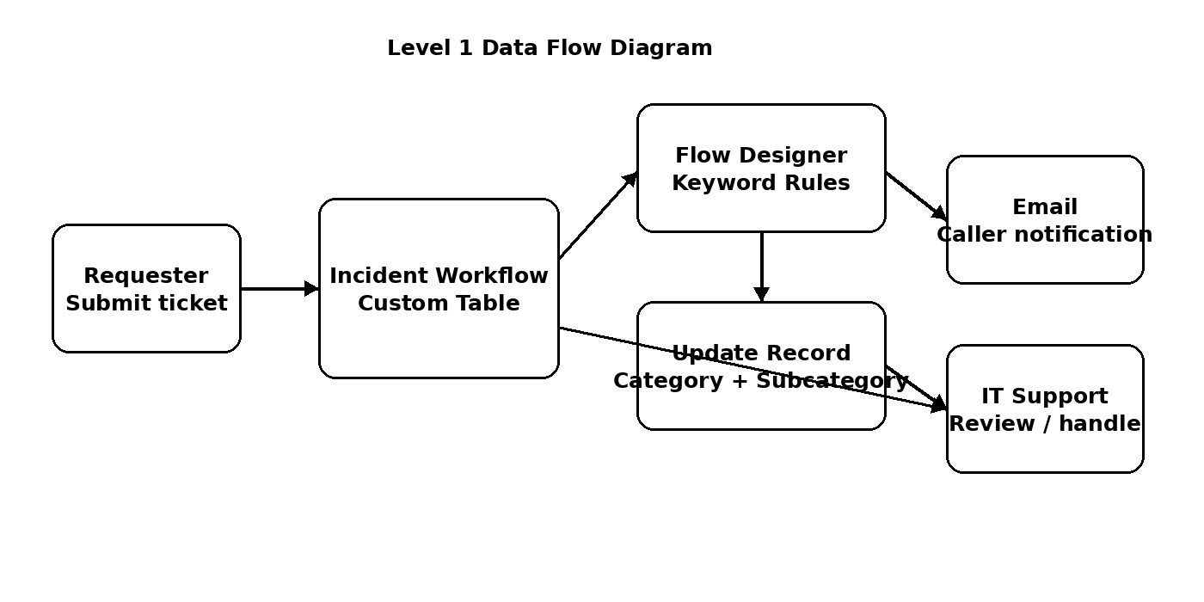
Figure: Data flow for ticket creation, rule-based classification, record update and email notification.

